**ECE 3544: Digital Design I**

**Project 1 (Part B): Simulation in the ModelSim Environment; Continuous Assignment Models**

Student Name: Jonathan Lemarroy

Honor Code Pledge: I have neither given nor received unauthorized assistance on this assignment.  
 __________________



**Grading: The design project will be graded on a 100 point basis, as shown below:**

Manner of Presentation (30 points)

Completed cover sheet included with report (5 points)

Organization: Clear, concise presentation of content; Use of appropriate, well-organized sections (15 points)

Mechanics: Spelling and grammar (10 points)

Technical Merit (70 points)

General discussion: *Did you describe the objectives in your own words? Did you address the questions posed in the project specification? Did you discuss your conclusions and the lessons you learned from the assignment?* (10 points)

Design discussion: *What was your approach to deriving the circuit you had to design?* *How does the design process that resulted in your continuous assignment model compare to the one you used to obtain a structural model that used primitive gates? How applicable is the design process you followed in this assignment to larger and more general designs?* (10 points)

Testing discussion: *What was your approach to formulating your test benches, and how did you verify the correctness of your design and implementation?* (10 points)

Supporting figures (20 points total)

* *Correct waveforms showing simulation of both decoder modules.* (5 points)
* *Correct waveforms showing correct operation of your design.* (15 points)

Supporting files: *Do the submitted files produce the correct response?* (20 points)

**Project Grade**

# Purpose:

The objective of this assignment is to gain experience using dataflow operators to implement a continuous assignment model. And to compare the functionality and code structure of using primitive gates versus the continuous assignment model.

# Project Description:

**Part 1:** Compare the differences of the sn74138 and the 4-to-16 decoder primitive gate implementations versus their continuous assignment implementations. Include screen shots of their testbench waveforms and comment on weather changing their implementation model affected the circuit’s behavior.

**Part 2:** Re-design and simulate a circuit using the continuous assignment model that can  
determine the winner of a rock, paper, scissors, lizard, or spock game between two players.  
Each player’s input consists of a 3-bit number with some of the possible combinations not being  
used. The outputs are a bit representing if player1 has won, another bit for if player2 has won, and a last bit if the game is tie. The bit representing a player should be logical true if they won or false otherwise.

# Technical Design:

**Part 1:** No design necessary.

**Part 2:** The first thing was to determine mappings for the 3-bit input combinations to a chosen representation of rock, paper, scissors, etc. Through some thought process and some trial and error to find combinations could easily be applied using Verilog’s dataflow operators, there was no clear evidence that the combinations had any effect on making an efficient design. Thus, the mappings chosen were the same as those found in Project 1A.

**Table 1: Input mappings**

|  |  |  |  |  |  |  |
| --- | --- | --- | --- | --- | --- | --- |
| Player’s Move | Rock | Paper | Scissors | Lizard | Spock | *Not Used* |
| Input Value(s) | 001 | 010 | 011 | 100 | 101 | 000, 110, 111 |

The next step was deciding the best operator to easily design this using the continuous assignment model. Because of the explicit statement not to use the exact design from Project 1A, the next easiest way was by comparing the concatenation of the player inputs to expected results found in **Table 2**.

**Table 2: Player combinations**

|  |  |  |  |  |
| --- | --- | --- | --- | --- |
| player1 | player2 | p1wins | p2wins | tied |
| ROCK | ROCK | 0 | 0 | 1 |
| ROCK | PAPER | 0 | 1 | 0 |
| ROCK | SCISSORS | 1 | 0 | 0 |
| ROCK | LIZARD | 1 | 0 | 0 |
| ROCK | SPOCK | 0 | 1 | 0 |
| PAPER | ROCK | 1 | 0 | 0 |
| PAPER | PAPER | 0 | 0 | 1 |
| PAPER | SCISSORS | 0 | 1 | 0 |
| PAPER | LIZARD | 0 | 1 | 0 |
| PAPER | SPOCK | 1 | 0 | 0 |
| SCISSORS | ROCK | 0 | 1 | 0 |
| SCISSORS | PAPER | 1 | 0 | 0 |
| SCISSORS | SCISSORS | 0 | 0 | 1 |
| SCISSORS | LIZARD | 1 | 0 | 0 |
| SCISSORS | SPOCK | 0 | 1 | 0 |
| LIZARD | ROCK | 0 | 1 | 0 |
| LIZARD | PAPER | 1 | 0 | 0 |
| LIZARD | SCISSORS | 0 | 1 | 0 |
| LIZARD | LIZARD | 0 | 0 | 1 |
| LIZARD | SPOCK | 1 | 0 | 0 |
| SPOCK | ROCK | 1 | 0 | 0 |
| SPOCK | PAPER | 0 | 1 | 0 |
| SPOCK | SCISSORS | 1 | 0 | 0 |
| SPOCK | LIZARD | 0 | 1 | 0 |
| SPOCK | SPOCK | 0 | 0 | 1 |

But instead of comparing the concatenation of every combination for each output, with just a little analysis one can easily deduce that tie combinations only occur when the players both play the same move. There fore using just the equality (==) operator the ‘tie’ bit can be set. And with a little more analysis it can be easily seen that player2’s winning bit should only be 1 when both the tie and player1’s input bits are set to 0. Therefor player2’s bit can be set to the NOR of the ‘tie’ and player’s bits.

# Analysis & Conclusion:

**Part 1:** Changing the implementation for the sn74138 and 4-to-16 decoder had no effect on their behavior, see **Figure 2** and **Figure 3**.

**Part 2:** To verify everything above was implemented correctly, the testbench used from Project 1A could be applied against this new implementation because they both maintained the same mappings from **Table 1**. And since the results found in **Figure 1** came out identical to those found in Project 1A this implementation is valid.

The thought process used for designing this implementation is useful/fast for larger scale designs, but as far as gate count and efficiency are concerned, this wouldn’t necessarily give us the optimal implementation that could be determined if Karnaugh map’s and primitive gates were used.

# Appendix:

**Figure 1: Game I/O simulation**

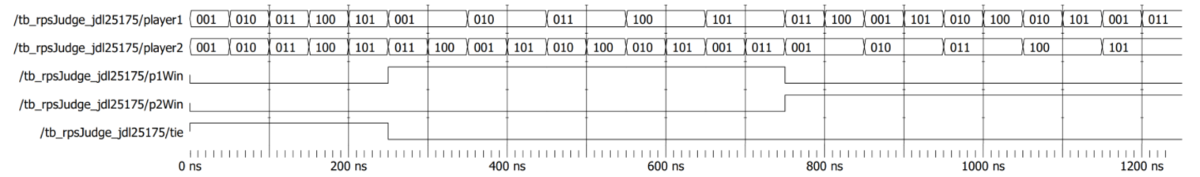

**Figure 2: 74138 3 to 8 decoder simulation**

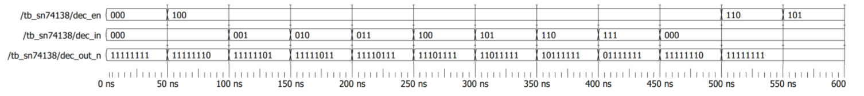

**Figure 3: 4 to 16 decoder simulation**

